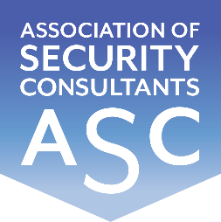

Certificate of Membership
This is to certify that
Andrew Crow RISC
has been enrolled as a member of the
Association of Security Consultants as a
Registered Independent Security Consultant
and is pledged to maintain its code of professional competence
and integrity.
Date of Enrolment: Membership No: Joe Connell
15th December 2022 FM 2207 Chairman

