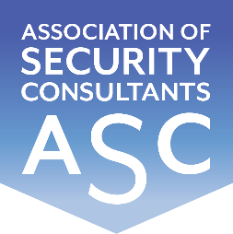

Certificate of Membership
This is to certify that
Mark Hayward RISC
has been enrolled as a member of the
Association of Security Consultants as a
Registered Independent Security Consultant
and is pledged to maintain its code of professional competence
and integrity.
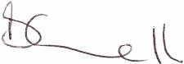
Date of Enrolment: Membership No: Joe Connell
4th April 2023 FM 2226 Chairman

