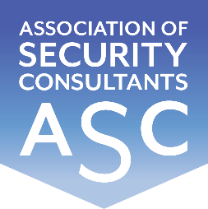

Certificate of Membership
This is to certify that
Jared Underwood RISC
has been enrolled as a member of the
Association of Security Consultants as a
Registered Independent Security Consultant
and is pledged to maintain its code of professional competence
and integrity.
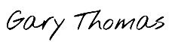
Date of Enrolment: Membership No: Gary Thomas
7th November 2023 FM 2242 Chairman

